Pune District Education Association’s
Seth Govind Raghunath Sable College of Pharmacy, Saswad
&
Pune District Education Association’s
Seth Govind Raghunath Sable College of Pharmacy (Poly.), Saswad
Joint activity Participation
Activity Report
Title of the event: Seminar on “Cooperative learning ”
Name of activity: Faculty Development Programme
Date and Day: 31/08/2023 Thursday Time: 02:30 pm to 04:00pm
Cooperative learning is a strategy used within groups of learners and aims to improve their learning experience and understanding of a learning subject. This type of learning strategy uses small group tasks and activities as a learning experience. Each member is responsible for learning new information and skills, and at the same time, assisting teammates in learning. In this view one day Faculty Orientation Programme for our faculty members on topic “Cooperative Learning” has been orgnized by the institute to assist teachers learn the use of cooperative teaching - learning effective. on 31st August 2023 at 11:00 am. Dr. Kuldeep Bansod Govt. college of pharmacy gave valuable guidance on Cooperative learning this programme to update their knowledge and skill in the field of education. Our faculty members are greatly benefited and are sensitized from his views and guidelines. The program ended with a vote of thanks by Ms. Smita Deshmukh. The activity conducted under the guidance of vice Principal Dr.Smita Pawar and Principal Dr. R.S. Chavan
Mrs.S.M.Deshmukh Dr. Rajashree Chavan

Photo Gallery (Faculty Development Program) 31/08/2023

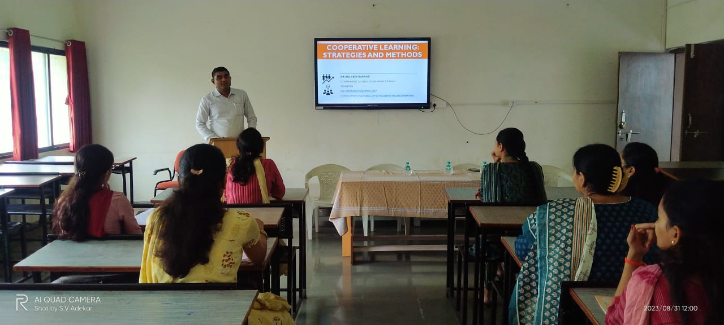

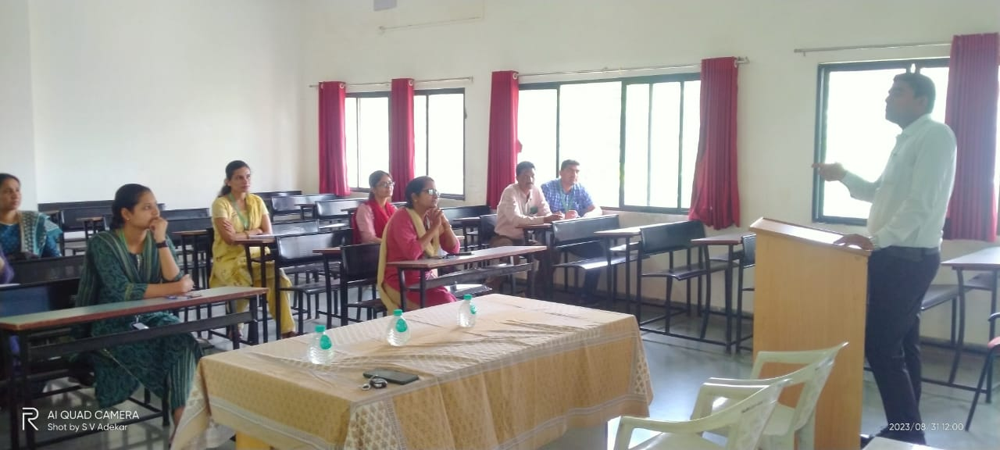

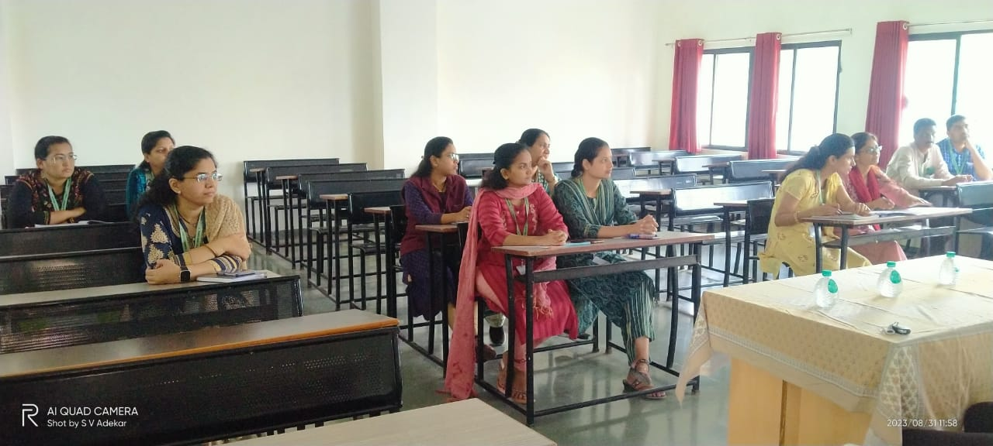

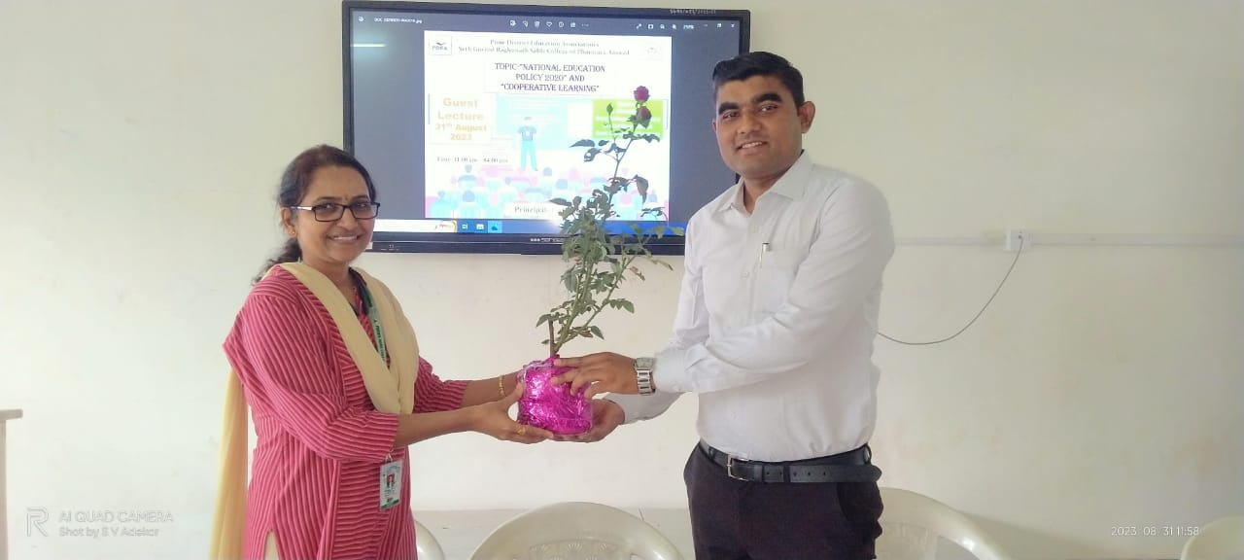

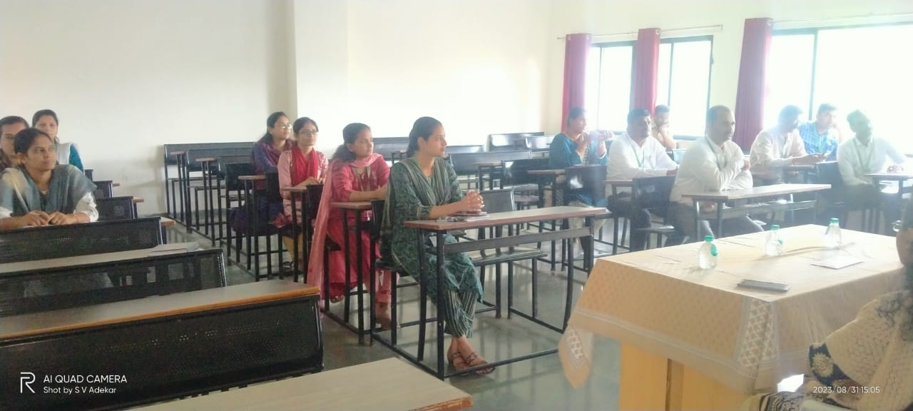
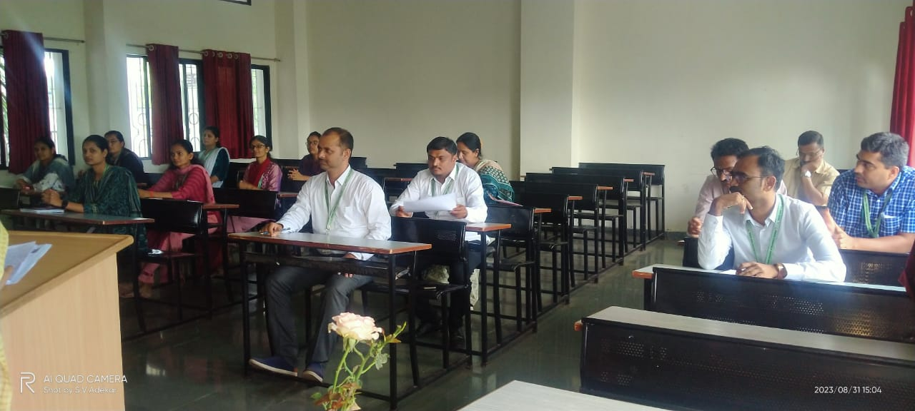

Dr. Rajashree Chavan
Principal

